Chapter 4, Problem 14.

Apply the superposition principle to find v_{o} in the circuit of Fig. 4.82.

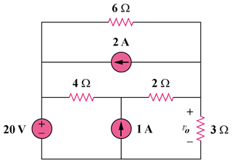

Figure 4.82
For Prob. 4.14

